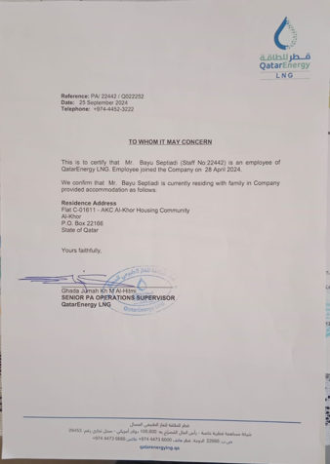

I will send the soft file tomorrow from office